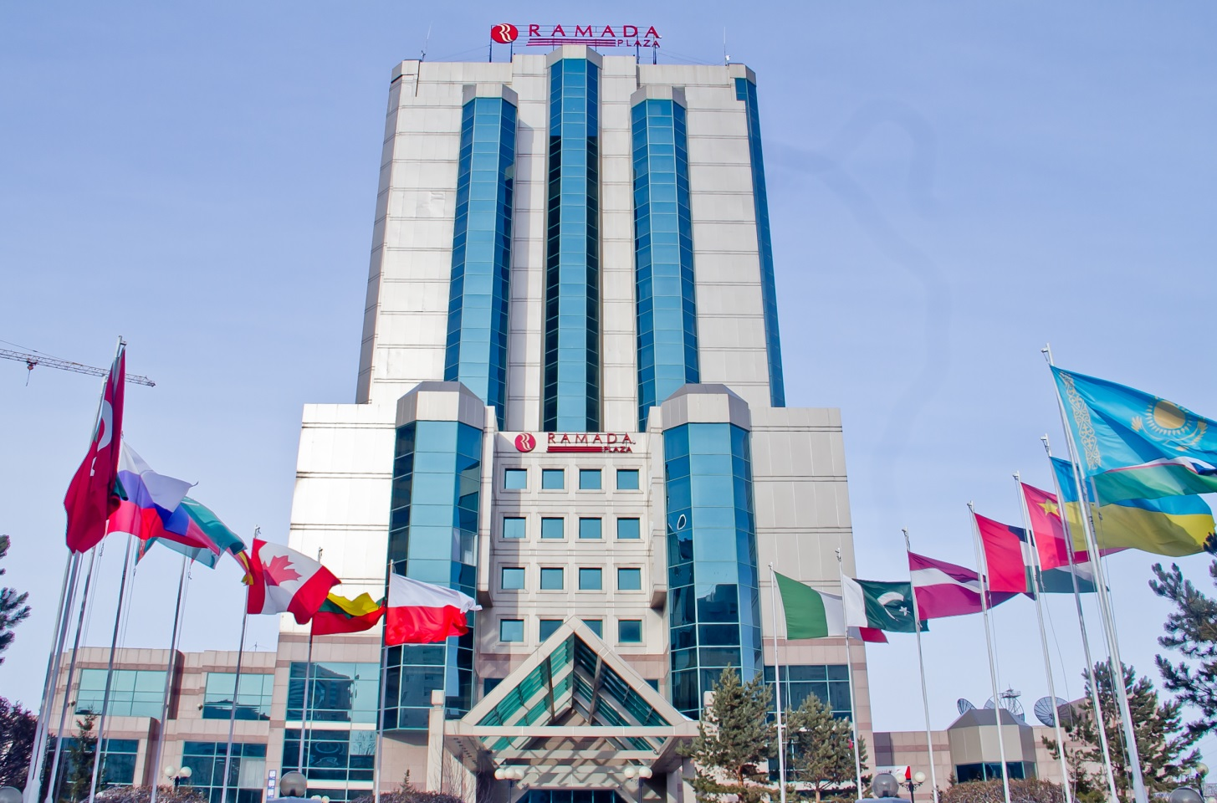

Hotel Ramada Plaza Astana
Republic of Kazakhstan, Astana, 010000,
Аbai 47
Tel: +7 (7172) 391 000
hotel@ramadaplazaastana.kz

Ramada Plaza Astana Hotel is the first five star hotel of Astana. Our team is ready to provide the highest service and warm Kazakhstani hospitality for your guests.
We are glad to offer you special rates for accommodation at our hotel.

Types of Rooms | Rack rate for 2016 | Your corporate rates for 2016 | Your corporate rates for 2016
 | Single Occupancy(with VAT in KZT) | Single Occupancy(with VAT in KZT) | Double Occupancy(with VAT in KZT)
“Deluxe” room | 67 200 | 30 000 | 35 000
“Superior” room | 78 400 | 35 000 | 45 000
“Executive” “Junior” suites | 100 800 | 45 000 | 65 000

- All rates include Buffet Breakfast at Marco Polo Restaurant (on the date following after arrival date), SPA Center facilities (swimming pool, sauna, gym) and free Wireless Internet access.
- Please note that our hotel check-in time is 2:00 pm, check-out is 12:00 noon.
- In case of a Guest arrival to the Hotel before official check-in time – 2.00 p.m. 50% of the cost of the room including VAT will be charged additionally for early check-in (from 06:00 a.m. to 2:00 p.m.). In case of early check-in breakfast will be charged additionally.
- Upon arrival earlier that 06-00 am, it is required to make a reservation beforehand, additional payment of 100% from the cost of special rate will be charged.
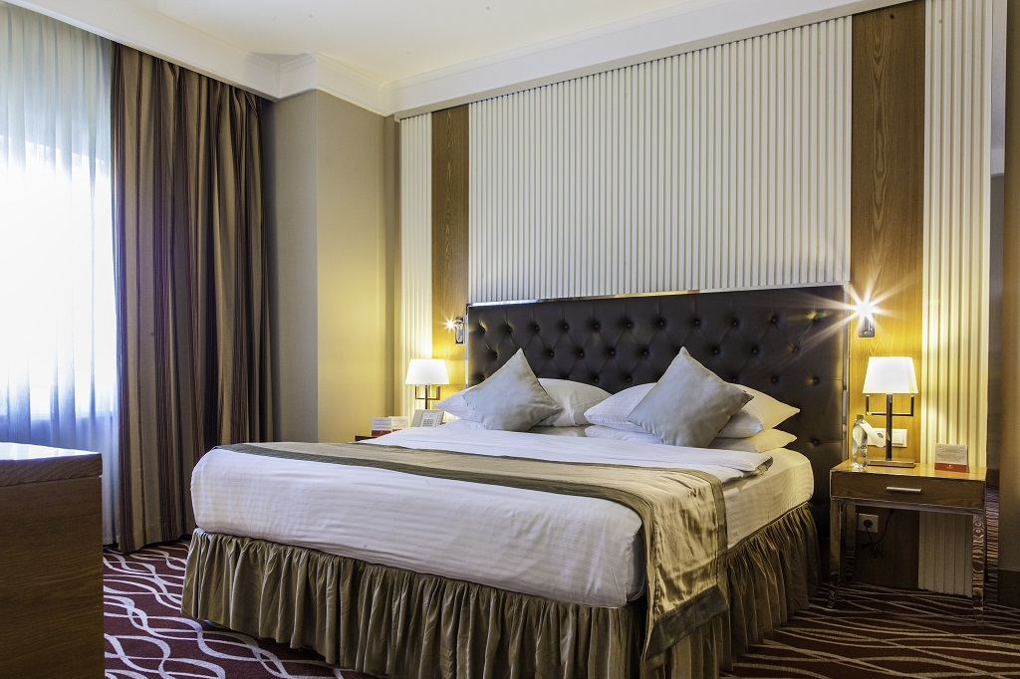

- In case of a Guest late-check out after official check-out time – 12:00 p.m. 50% of the cost of the room including VAT will be charged additionally for late check-out (from 12:00 p.m. to 6:00 p.m.).
- After 6:00 p.m. hotel charges 100% of special rate for one night.
- Additional services: a free car parking, a business-center, laundry, rental car and airport transfer.

Booking and cancellation terms:
- Rooms and other services can be ordered by any of below mentioned methods:
Reservation Department:
fax: +7 (7172) 391012.
E-mail address: hotel@ramadaplazaastana.kz.
You will receive a reservation number as a confirmation of your booking.

Payment terms:
- In accordance with the article 282 of Civil Code of RK, which is displayed at the Front Office Desk daily, all the prices and services to be paid in KZT according to the internal hotel exchange rate. Hotel has a right to change internal rate without any written prior notification (at the moment $1 – KZT 360).
- The Hotel is not responsible if any additional taxes/charges are imposed by the Government during the time this proposal is in effect. All such taxes shall be charged to and bared by the Company.
- In case of bank payment, all bank charges should be at Company’s expense.
- Payment is accepted in tenge, Master card, American Express, Visa card payments are also acceptable

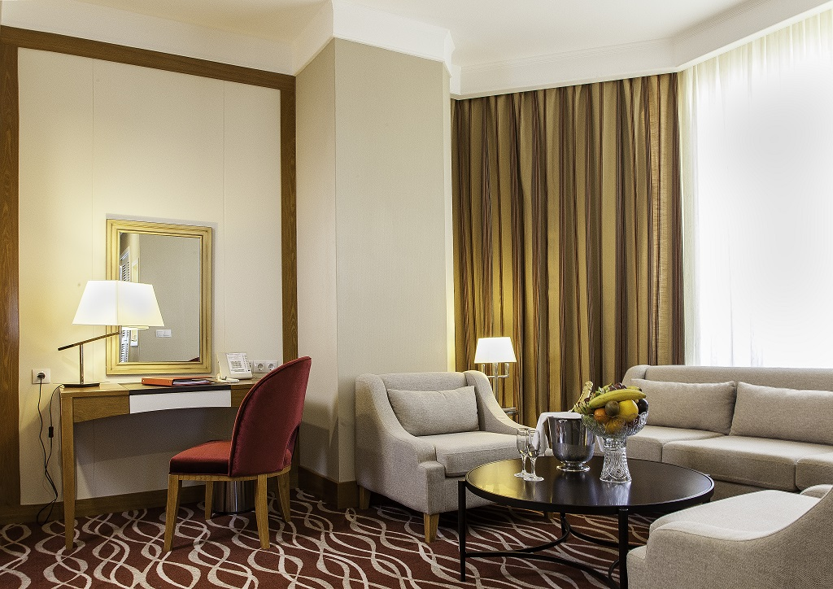

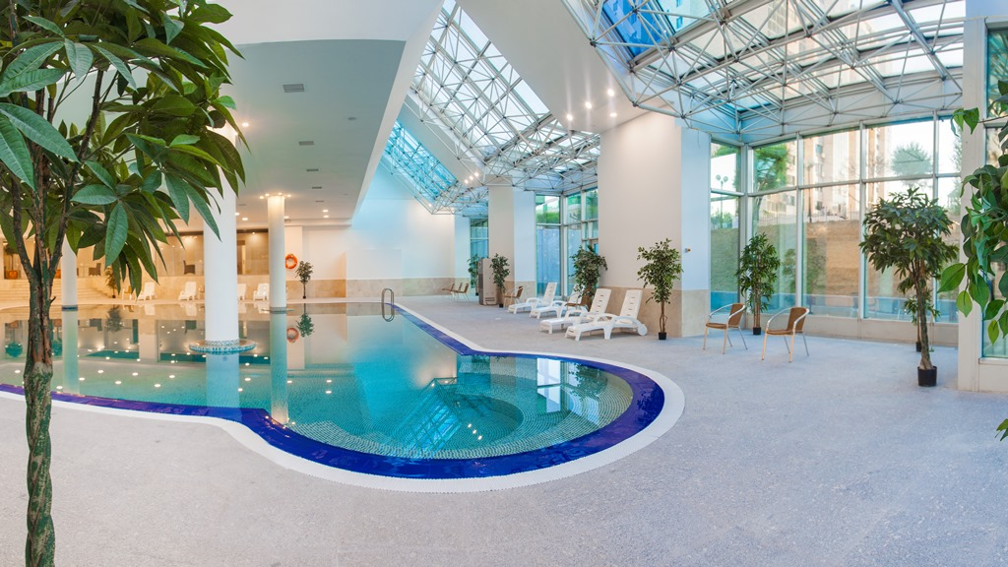

Loyalty Program «Wyndham Rewards»

Guests staying in the Hotel Ramada Plaza Astana can join the loyalty program «Wyndham Rewards». This program allows the guests to collect points for free accommodation in more than 7500 hotels around the world, to earn miles of our partner airlines. More information is available on the website: wyndhamrewards.com.

